APPENDIX 4
Temporal diving patterns and relationships between diving and movement speed of Marbled Murrelets captured off the central Oregon coast, May 2016: proportion of satellite fixes by hour during which individuals were engaged in diving behavior
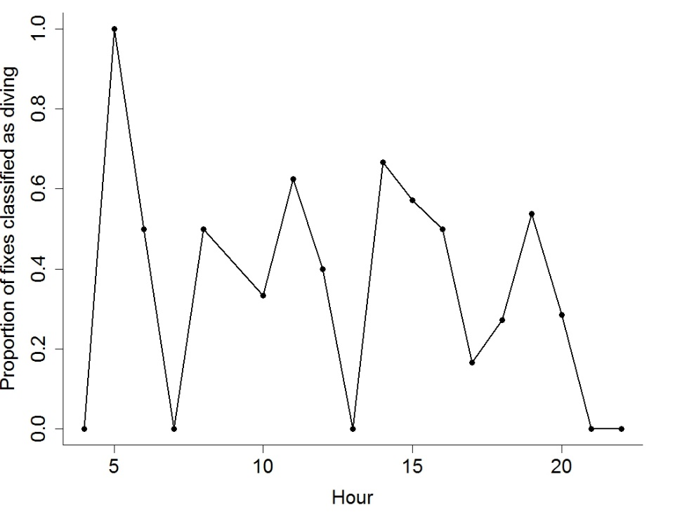
Marbled Murrelet 160348

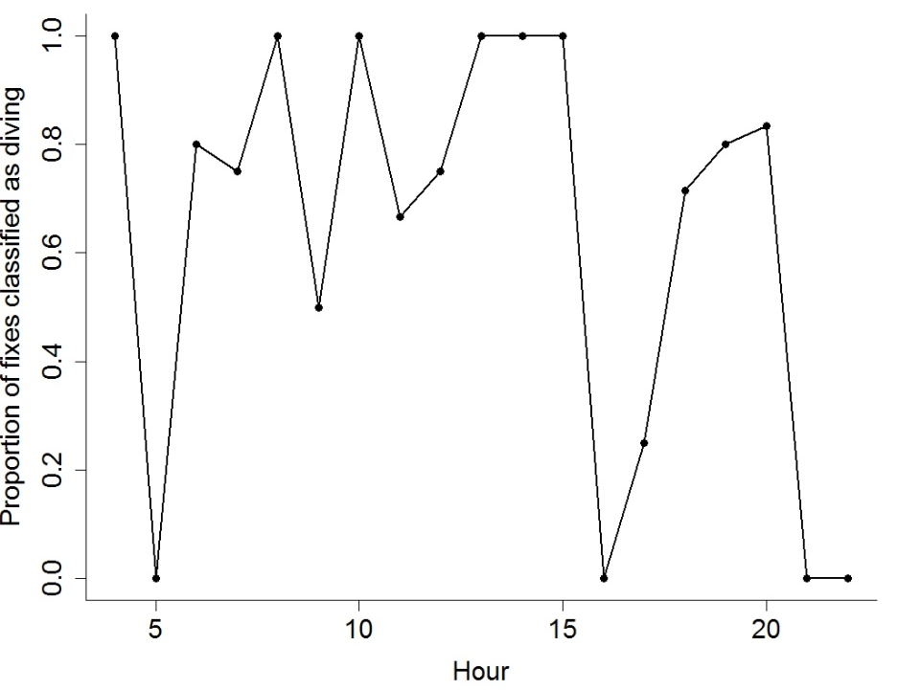
Marbled Murrelet 160349.

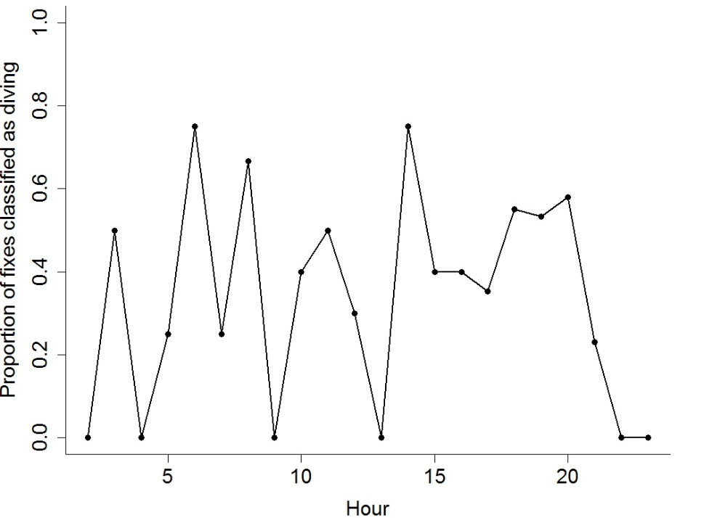
Marbled Murrelet 160350

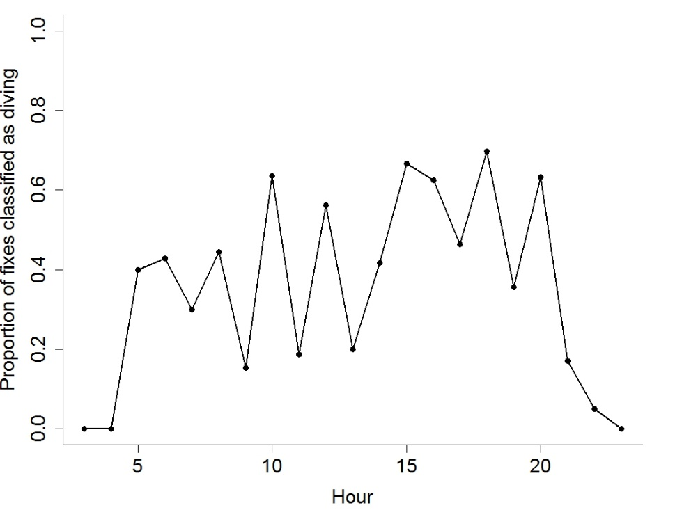
Marbled Murrelet 160351
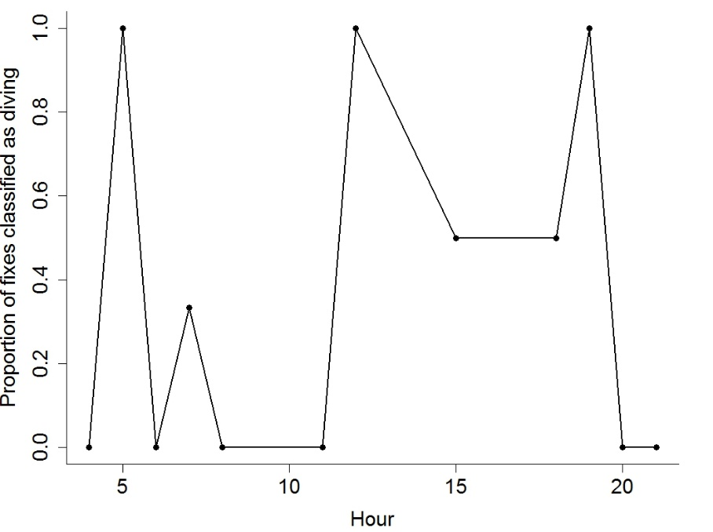
Marbled Murrelet 160352
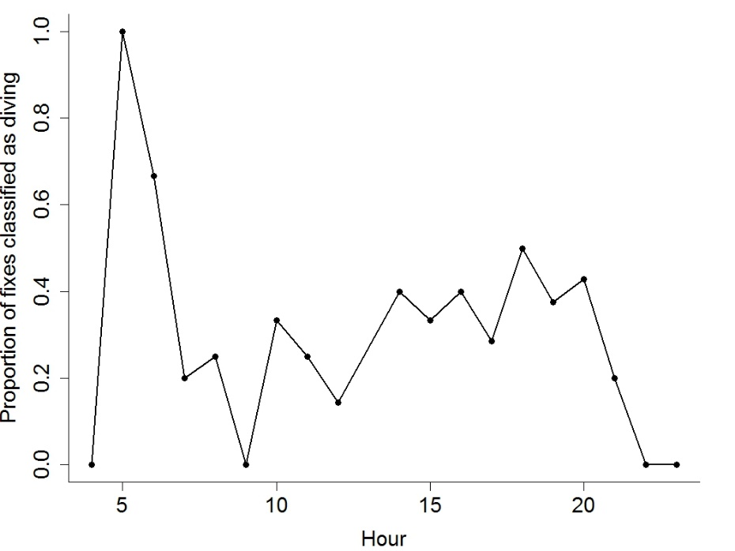
Marbled Murrelet 160354

Results of logistic regression models of diving as a function of the estimated speed of murrelets from continuous-time correlated random-walk models, May 2016.
Murrelet | Intercept (p-value) | Speed (p-value)
All | -0.90 (<0.001) | 0.04 (0.62)
160348 | 0.24 (<0.001) | -0.05 (0.27)
160349 | 0.49 (<0.001) | -0.13 (0.04)
160350 | 0.28 (<0.001) | -0.002 (0.93)
160351 | 0.28 (<0.001) | 0.03 (0.21)
160352 | 0.22 (0.02) | -0.07 (0.46)
160354 | 0.25 (<0.001) | 0.05 (0.29)

